Popsicle Stick Bridge
By drinkmorecoffee in WorkshopScience
1,451,397
198
165
Featured
1 Teacher Note

Introduction: Popsicle Stick Bridge
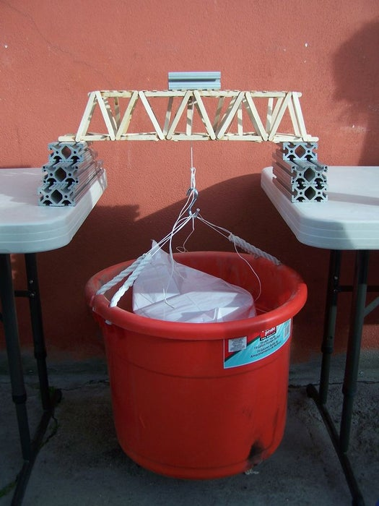

About: Ask me questions. I know the answers. More About drinkmorecoffee »
The popsicle stick bridge is a classic science demonstration and competition. Every year many students world-wide build bridges made soley from popsicle sticks and glue, to see which designs can hold the most weight.
We built one, using maybe 140 sticks, give or take a few. Not expecting it to hold much weight, we were surprised by how strong it ended up being! (Results in last step)

Step 1: Design Your Bridge
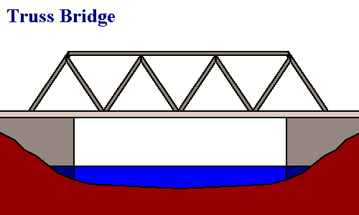
There are many ways to build bridges, both real bridges and popsicle stick bridges. Do some research, be creative, and remember - triangles are strong.
A triangle spreads out weight and is much more stable than a simple rectangle or square support. Be sure to incorporate lots of triangles into your bridge design. More popsicle sticks doesn't necessarily mean a stronger bridge.
In fact, according to the internet, "If there is a single most important shape in engineering, it is the triangle. Unlike a rectangle, a triangle cannot be deformed without changing the length of one of its sides or breaking one of its joints. In fact, one of the simplest ways to strengthen a rectangle is to add supports that form triangles at the rectangle's corners or across its diagonal length. A single support between two diagonal corners greatly strengthens a rectangle by turning it into two triangles."
My design consists of two main bottom supports, and two across the top, and then a lot of triangles across the sides, the top and bottom, and going from the bottom of one side to the top of the other. Very similar to the one in the diagram.
Draw your design on paper, and estimate the number of sticks you will need. Be creative with your design!

Step 2: Supplies
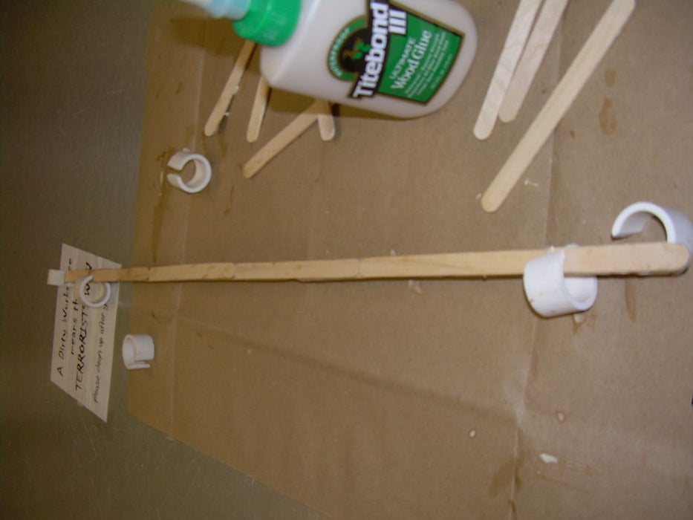
Very, very simple:
-Popsicle sticks
-Wood glue
-PVC (optional)

Step 3: Constructing
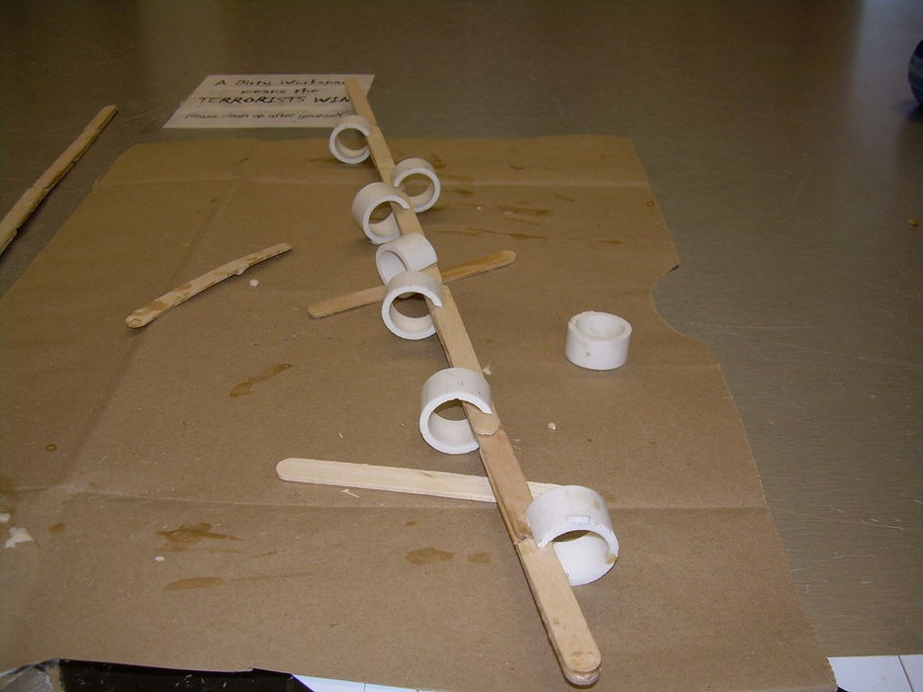
Some things to keep in mind:
A clamp of some sort is a good idea when constructing. I used Tim Andersons method, but bulldog clips work just as well. Clamps are important because most of the popsicle stick aren't flat, so if you don't clamp them when you glue them together your bridge probably won't hold together very well.
Don't pinch your fingers.
Keep your workspace clean! I glued everything on top of a piece of paper, as I have a tendency to get glue everywhere.

Step 4: Start Small
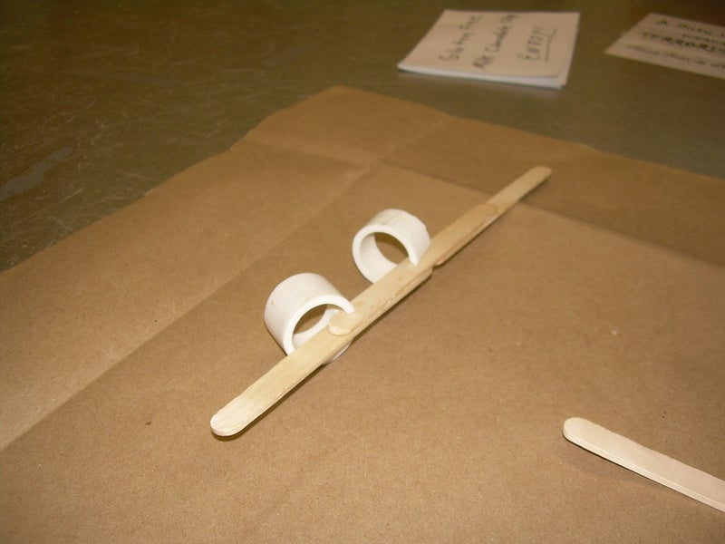
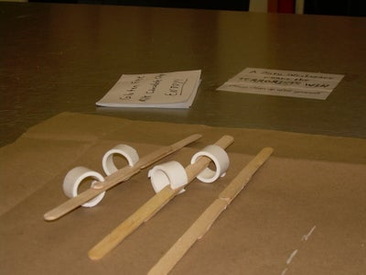
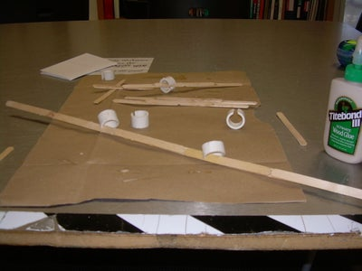
I started by making smaller pieces that would be easier to glue together. I counted out how many I needed and started with that. Once they'd dried just enough to not fall apart, I moved on.

Step 5: Get Bigger...
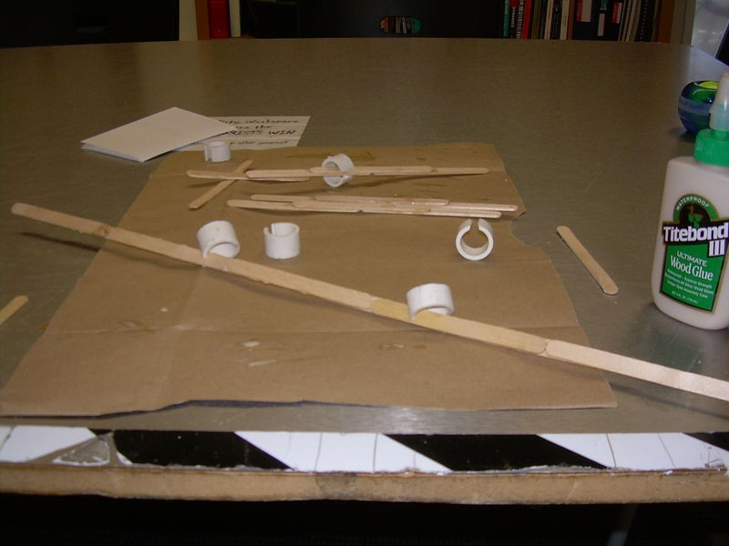
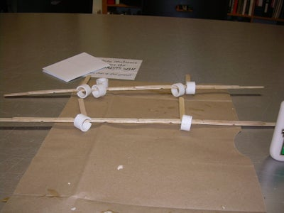
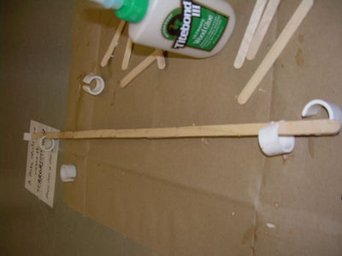
I glued the smaller pieces together, to create the main supports for the bridge. I then repeated the process and made some slightly shorter pieces for the top.

Step 6: Add Supports
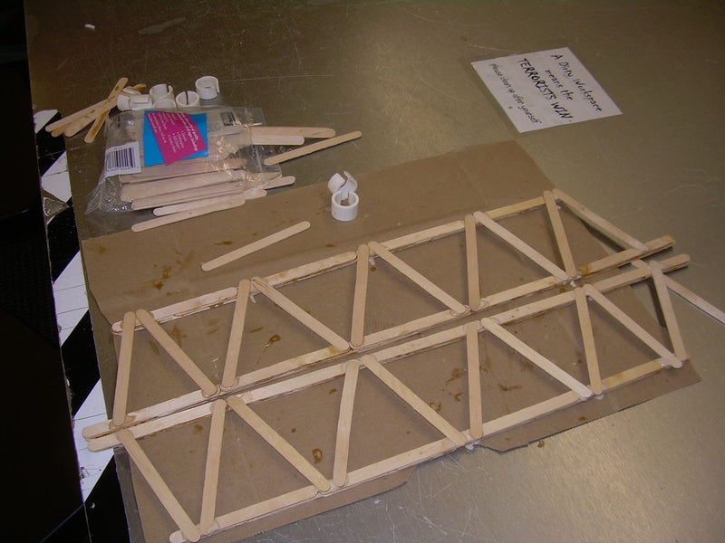
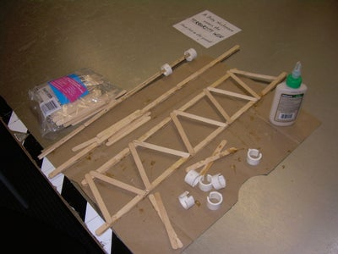
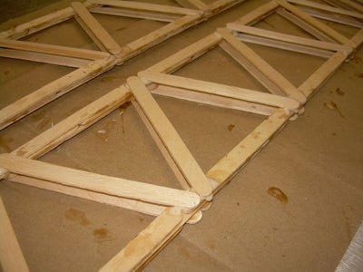
I started with each side of the bridge, keeping them symmetrical, then flipped each side and added more.
Add TipAsk QuestionCommentDownload

Step 7: Add MORE Supports
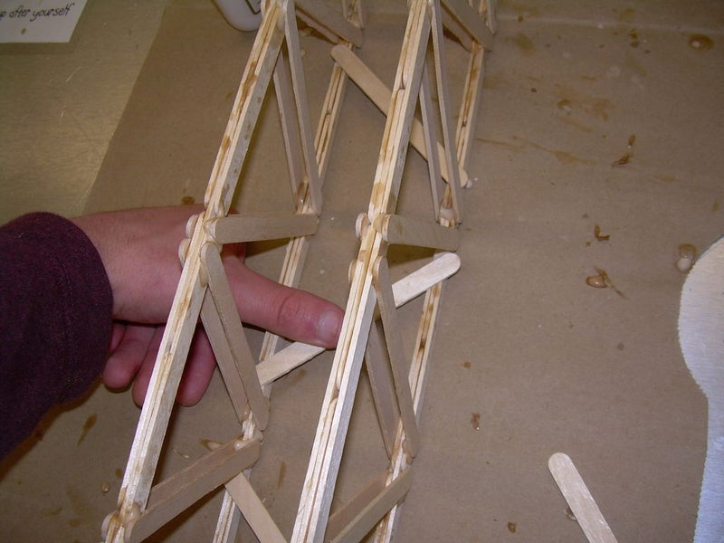
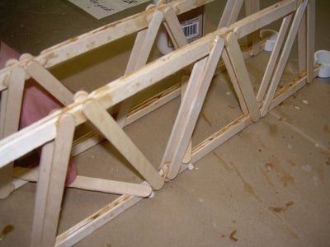
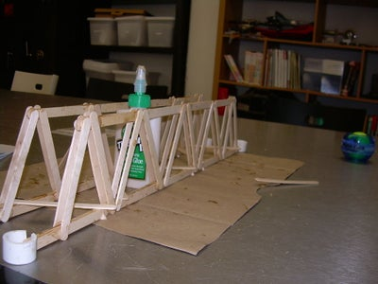
3 More Images
I added angled supports across the bottom to start with, to hold it together, then across the top.
Keeping in mind the idea that triangles are strong, I added some center supports going across as well as up and down.

Step 8: Finish It Off
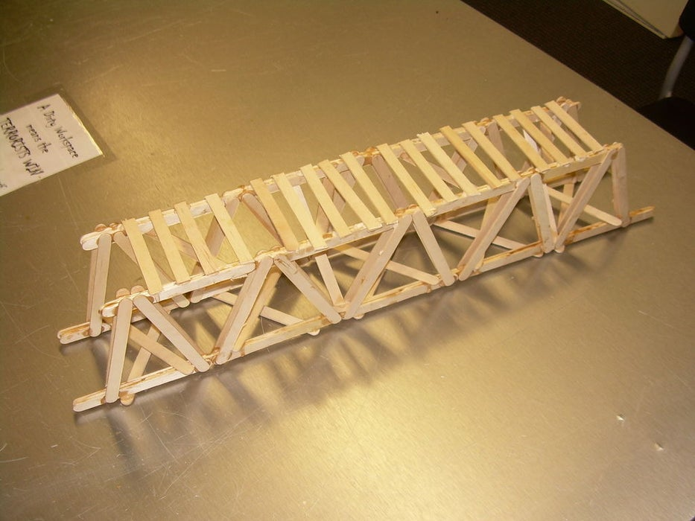
I finished it off with some pieces across the top. I'm not sure they add any structural support, but they look good.
I also touched-up on the glue where it was looking scarce, and added more horizontal supports.
Lastly I sanded the top, to make it completely flat so that weight wouldn't be focused on any one point

Step 9: Break It! (Or Try)
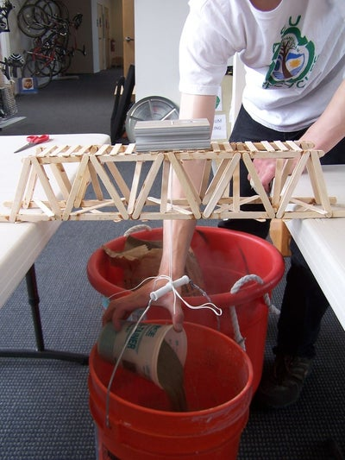
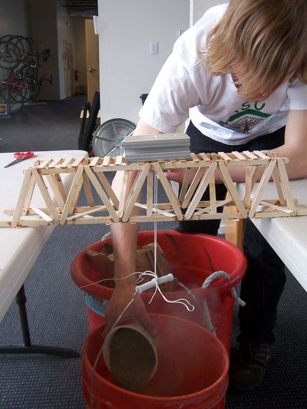
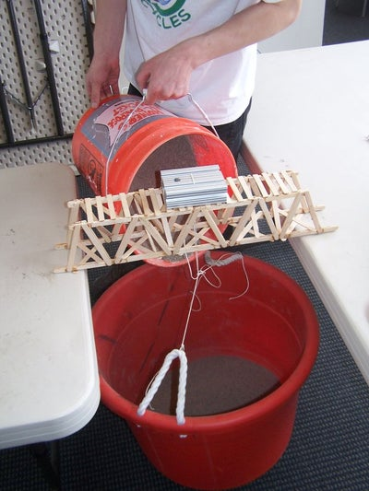
17 More Images
This is the last step, obviously.
We decided we'd test the bridge with sand in a bucket. We bought two 60 lb bags of sand, thinking surely my bridge would break under 120 lbs.
It held 120 lbs.
We emptied the sand out, and added 40 lbs of water, then added all the sand back. It still held.
We tried the intern, and it still held.
Two days later we bought another 150 lbs of sand. The bridge finally broke under 205 lbs!
How much does yours weigh?

